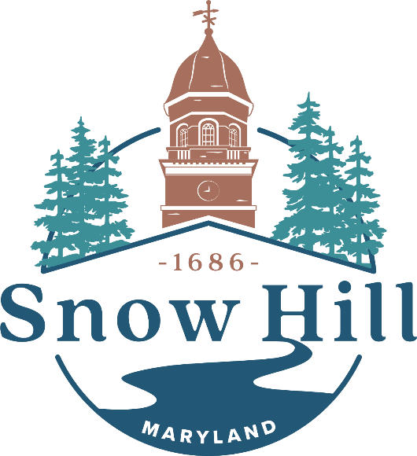

Water / Wastewater Assistance Programs &
Resource Research Report

Prepared by Gerald L. Jeffra III
Date Created: March, 2023
Latest Update: October, 2023
Contents

Introduction……………………………………………………………...…...…… 3
Explanation of Gallons & New Rates Breakdown…...…………………….………4
Purpose & Goal………………………….……….…………………….…………. 7

County/State/Federal
Maryland Department of Human Services (DHS)…………………….…….…….8
Worcester County Department of Social Services (DSS)……….………….….….11

Local/Religious/Non-Profit Organizations
2-1-1 Maryland………………………………………….……….….…………….12
Diakonia Inc………………………………….…………………….….…….……13
Dollar Energy Fund………………………………….…….……………...………14
The Joseph House………………………….………………….………….……….16
Salvation Army (Salisbury)……………….………….………………….….….…17
Seton Center (Catholic Charities Diocese of Wilmington).……...………....….…18
SHORE UP! Inc………………………………………………………….….……19
Worcester Youth & Family Counseling Services………...…………………….…20
Worcester County GOLD…………………………….……………...……………21

Churches/Ministries………………………….………….……………….….……22
References……………………………………….……….....................………….25

Introduction
Over the past several years, the overall operating costs for Snow Hill’s Water & Wastewater facilities has been driven deep into the red due to the increase in cost of chemicals, debt services and the inadequate rate proportionate to reflect the ever-increasing expenditures. Jean S. Holloway, Delaware & Maryland State Lead of SERCAP, provided to the town a no-cost rate analysis report which included projected deficit amounts, the cost per gallon at which the Town is operating on, the rates at which cost recoveries should be set at, and the serious implications of failing to course correct sooner than later (2023).
To highlight the urgency, this passage from Holloway’s report capsulates the ongoing crisis and the coming disaster:
The current water and sewer rates do not appear to be based on full-cost recovery principles… The Sewer System is being operated at a serious deficit and appears to have been in a deficit position for at least a few years. It’s important to understand that a zero balanced budget does not mean a utility is fully recovering its costs of operation if it does not cover reasonable reserves and/or allocable costs of general government. This appears to be the case with the sewer with a projected deficit of $595,242 for the test year of FY 2023. The Water Utility is [in] better shape but a deficit of $67,981 is still projected for the same test year. Neither the Water or the Sewer utility is financially sustainable under the present rates and rate structure.
Failing to address this will put the utility farther in the red and seriously jeopardize any attempt at securing funding for future upgrades or expansion. (2023, p. 4)
The Town faces additional consequences from the state of Maryland should the department neglect to course correct in the near future. The solution is therefore, but certainly not an easy one: to increase both the customer charge and rate per gallon allowance of both the Water & Wastewater, with a much more significant increase in the Wastewater to begin reversing the damage and taking the facility back to a self-sufficient operating body. The ordinance to pass the increases for both water/wastewater rates was on June 13th 2023. Though the increases are scheduled to start on July 1st 2023, the billing of these rates would not begin until October 2023 and would nonetheless be a sudden and drastic spike in rate fees for the citizens of Snow Hill.
Explanation of Gallons & New Rates Breakdown
While Holloway’s report suggested a new rate for the Town to adopt, it’s important to first understand the current system the Town of Snow Hill has implemented and how it has affected the decisions made.
Each customer is charged a fixed “customer rate,” per quarter, for their water and wastewater. While the water and wastewater each have their own separate customer rate, both of them have a “gallon-allowance” amount of 6,000 gallons. A gallon-allowance is how many gallons the customer can use during a quarter before being charged extra on top of the customer rate. Therefore, a gallon-allowance of 6,000 ensures that, as long as the customer uses 6,000 or less gallons, they will be charged only the customer rate for both water and wastewater. However, should the customer go over the 6,000 gallon-allowance, they will be charged a fee proportionate to how many gallons they use, with 1,000 gallons after the gallon-allowance as a benchmark on how exactly much more it would cost. In calculating the total gallon usage, wastewater is based on the customer’s water usage. Each of the two categories, water and wastewater, have a different cost rate per 1,000 gallons after the 6,000-gallon allowance has been used, and at the end of each quarter the bills for the two services are combined as one.
As an example of using over the allowance: in one quarter a customer used 10,000 gallons. The meter would count this amount of gallon usage, and the Town receives the information. Since the customer used 4,000 gallons over the 6,000 gallons, they would be charged additional fees, per 1,000 gallons, proportionate to each of the different fees in both water and wastewater. Using the older rates, this additional fee would be $46.36.
The following is the old customer rate and per 1,000-gallon rate fee after the gallon allowance has been exhausted:
Water: Customer Rate – $39.89. If gallon usage is over 6,000 gallons, will be charged up to $5.90 per 1,000 gallons used.
Wastewater: Customer Rate - $73.47. If gallon usage is over 6,000 gallons, will be charged up to $5.69 per 1,000 gallons used.

This page will now describe the newly proposed rates for both water and wastewater for the Town of Snow Hill to issue, which have since been adopted.

The following is the new rate for water usage.
- Gallon Allowance of 6,000, charged $7.70 per 1,000 gallons after the 6,000.
The customer rate has also risen from its previous rate of $39.89 to $50.00.

The following is the new rate for wastewater/sewer usage.
- Gallon Allowance of 6,000, charged $12.35 per 1,000 gallons after the 6,000.
The customer rate has also risen from its previous rate of $73.47 to $135.00.

If a customer were to stay within the gallon allowance, under the new rate, they would be expected to pay $185.00 per quarter for just their water and wastewater services, an increase of $71.64 per quarter from the previous rate. Staying under the gallon allowance, a customer would be paying $740.00 annually just with the base rate, an increase of $286.56 per year from the previous rate. Including trash collection ($20.00), BRFF (Bay Restoration Fund Fee, $15.00) and CAP improvement fee ($2.50), the actual minimum cost per quarter is $222.50.
To find the best possible rates given the Town’s usage rates, Holloway’s study also included an average gallon usage per quarter, based on a 1,000-gallon block relevant to Snow Hill’s populace (2023, p.10). There, it shows that just under 75% of customers consume 15,000 or less gallons per quarter, with 28.4% using 4,000 or less gallons per quarter (Holloway, 2023, p. 11). With this information in mind, the Town of Snow Hill was poised to pick a rate structure that the residents were already familiar with, and more importantly, having the least economic impact on its citizens.
Displayed on the next page are graphs created by Holloway to demonstrate how the current cost compares with the new rate on an annual basis. This information was also deliberated by the Town to best decide which rate to consider reasonable for its citizens.
Water Rates, compared and contrasted with current and the new rate.
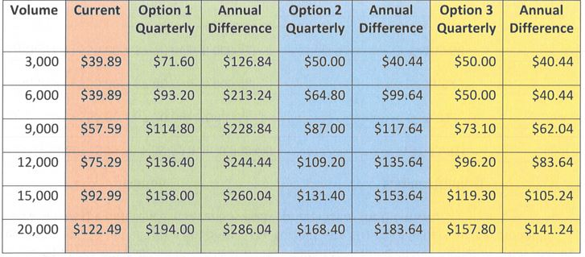
(Holloway, 2023, p. 12)

Sewer Rates, compared and contrasted with current and the new rate.
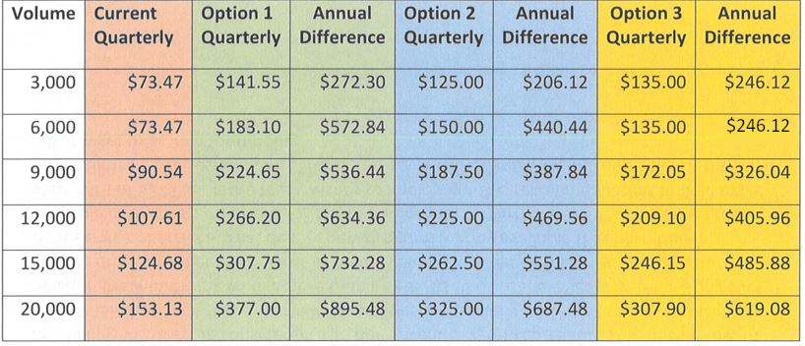
(Holloway, 2023, p. 20) (Edited by Gerald Jeffra)

To put a percentage to it, the annual difference in the newly adopted water rates compared to what it was is a 25.34% increase, whereas the sewer rates is an 83.75% increase.
Purpose & Goal
With a population of under 2,500, a poverty rate of 22.8%, and a median household income of just above $50,000, the Town of Snow Hill’s challenge rests with keeping utilities at an affordable rate as much as possible (U.S. Census Bureau, 2021). It is then the intent of this report that for Town to make known resources readily available for the citizens to use as relief in preparation and for when the rate increase takes effect. The remaining document contains an organized list of sources that citizens can use and obtain more information for themselves and others should they qualify within the programs’ requirements. Most of these agencies/programs/services also offer alternative reliefs for other needs, such as housing, employment, food, shelter, education and child programs, and many more. These could be vital in taking the costs that would be otherwise used in these expenses and help supplement payment for the water and wastewater fees. Some of the agencies also offer the opportunity to take advantage of multiple benefits at the same time as others, providing further relief when needed.
While the Town appreciates the challenges this will put on our citizens, it is also vital to understand the stakes. Should the Town continue to run as is, or not to make significant strides to begin recouping the losses that the water and wastewater facilities are generating, the Town could lose its licensing, starting with hefty fines issued to the Town by the State Department of the Environment. Should the Town continue to operate as it had been, at its worst, the state would replace the department with a much heavily for-profit driven module that would cost the citizens drastically more than what the Town’s new rates are now.
The Town continues to remain true to its commitment to serving its people by rectifying past missteps and to face the current and unpredictable climate of the nation’s economy. It is through this demonstration of providing a wealth of resources of information, explanation, and contacts that the Town urges all citizens to help spread the word of both this document, its contents and the coming changes to the water & wastewater rates. The history of Snow Hill has been rich in moments of resilience, steadfastness and determination in creating the beautiful and welcoming town it is today. Through that same spirit and community outreach is how the citizens of the town of Snow Hill will persevere, and by following the inspiration created by its people, the Town will continue its relentless search to one day ease these and many other burdens from its residents it so faithfully serves.
County/State/Federal
Maryland Department of Human Services (DHS)
Phone: 1-800-332-6347 (State Number), OR 410-632-2075 (Local Office)
Email/Contact:
- dhs.maryland.gov/office-of-home-energy-programs/contact-us
- energywicomico@shoreup.org (Local Office)
Website: mymdthink.maryland.gov
Address: 6352 Worcester Highway Newark, MD 21841 (Local Office)

State department funded resource eligible to Marylanders. The program specifically to assist with affording water & wastewater utilities is LIHWAP, Low Income Household Water Assistance Program, a federal sourced program. Residents do not necessarily need to have a turn off notice to qualify and are encouraged to apply before possible turn-offs. Those who apply must complete an application process, which is accessed through their website. There, applicants will need to create an account and proceed until completion. Some of the information needed is, but not limited to, a copy of your most recent water/wastewater bill and/or turn off notice, proof of your household’s total gross in the last 30 days, proof of residency, copy of applicant’s photo identification and more.

A list of acceptable documentation can be found here:
dhs.maryland.gov/office-of-home-energy-programs/low-income-household-water-assistance-program/acceptable-documentation-water-assistance

The total amount of relief is also dependent on the applicant’s/household total gross income and could be provided with up to $2,000. Applicants who are enrolled in certain other programs, such as Supplemental Nutrition Assistance (SNAP), Supplemental Security Income (SSI), Emergency Rental Assistance (ERAP), Low Income Household Energy Assistance (MEAP) and more may still be eligible to also receive benefits from LIHWAP.
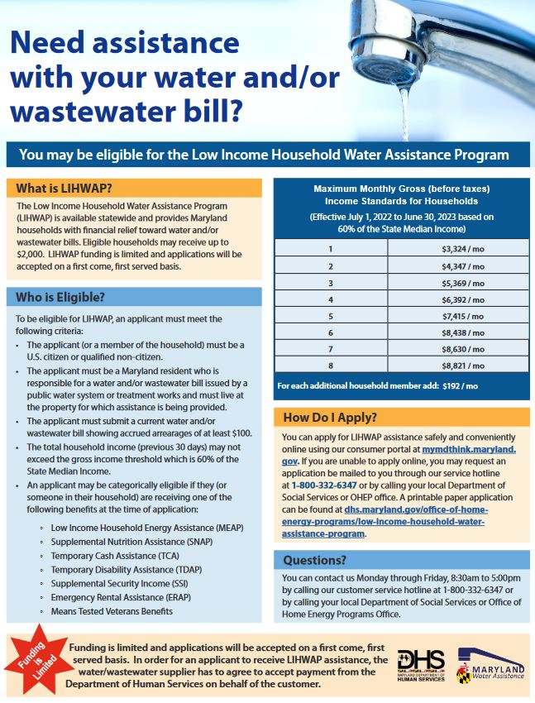
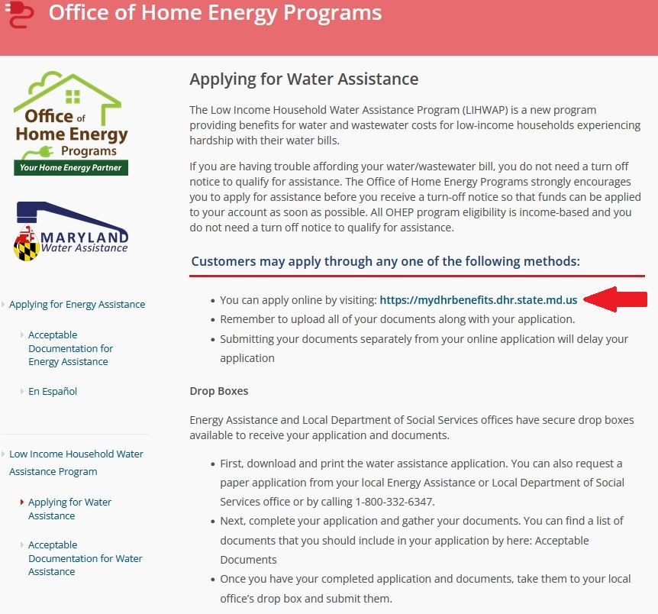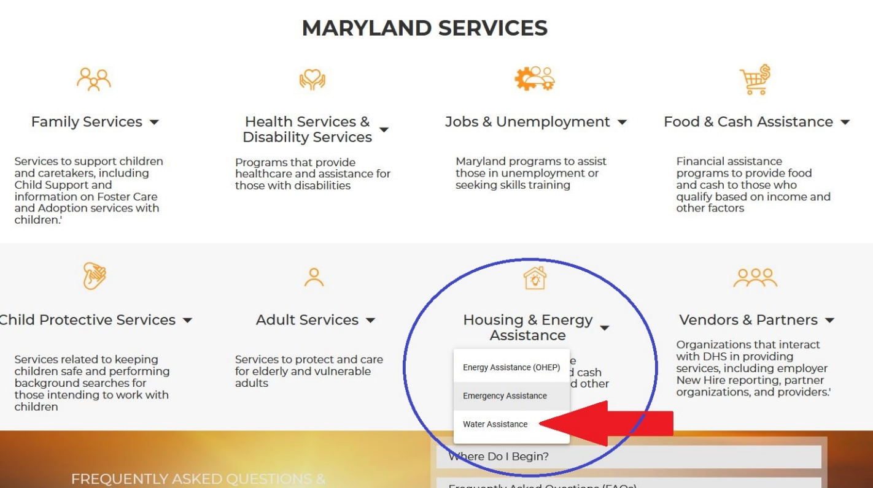

Worcester County Department of Social Services (DSS)
Phone: 410-677-6800, for Justin Taylor 6906
Email/Contact: worcester.dss@maryland.gov
Website: dhs.maryland.gov/local-offices/worcester-county
Address: 299 Commerce Street Snow Hill, MD 21863

Worcester County department hosting a multitude of programs and services for its residents. Upon contacting Social Services, Department of Social Services would then refer the case over to Worcester County Gold, and, if eligible, would then grant the applicant relief for their disconnect. Some details to take note of are:
- A person can only apply and receive funds once a year.
- They can be given up to $400 in relief on a disconnect.
- The applicant MUST pay the difference before the relief fund can become effective; the $400 will only cover the remaining balance up to that amount. (If the applicant owes $500 in water/wastewater expenses, they must first pay $100, so that the remaining balance is $400 or less, which Worcester County Gold will then pay the rest of.)

Consult the following picture for documentation when ready to apply:
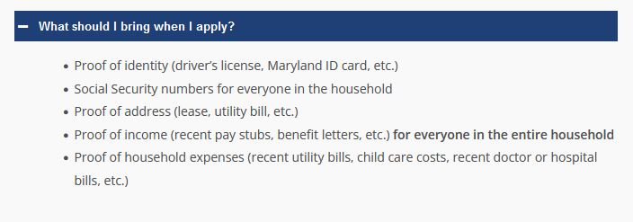

Local/Religious/Non-Profit Organizations
2-1-1 Maryland
Phone: 211 -OR- Call 711 for hard of hearing/deaf
Email/Contact: search.211md.org
Website: 211md.org
Address: 9770 Patuxent Woods Drive, Suite 334 Columbia, MD 21046

A non-profit organization that acts as a sophisticated and comprehensive database for local and state agencies of all categories of needs, such as food, COVID-19 resources, health care, legal services, utility assistance and more. While 2-1-1 does not provide the funding themselves, they are similar to Worcester Youth & Family Counseling Services in that they would assist an applicant in finding agencies and sources of relief that they would be eligible for. The site offers a powerful searching tool that allows a user to search for the service they are interested in, the address, and distance in miles. They can find this map at: search.211md.org
They offer a service to talk to live agents, and is suitable for residents who may not have access to / know how to use the internet by calling them at 211
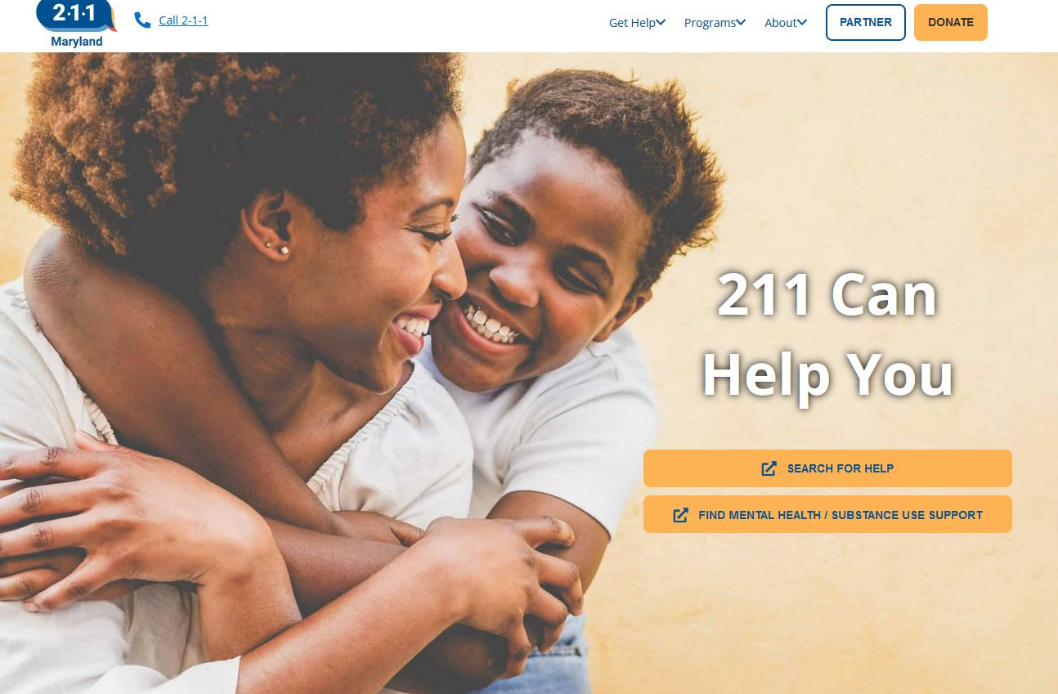
Diakonia Inc.
Phone: 410-213-0923
Email/Contact: info@diakoniaoc.org
Website: diakoniaoc.org
Address: 12747 Old Bridge Road Ocean City, MD 21842

Offering a majority of its services to homeless, Diakonia is a non-profit organization located locally in Ocean City. Currently, funding for non-veteran citizens has ran out until October 2023, whereas they still have funding available for veterans. However, once funding has resumed in October, they would be able to provide water and sewer relief assistance to non-veteran residents.

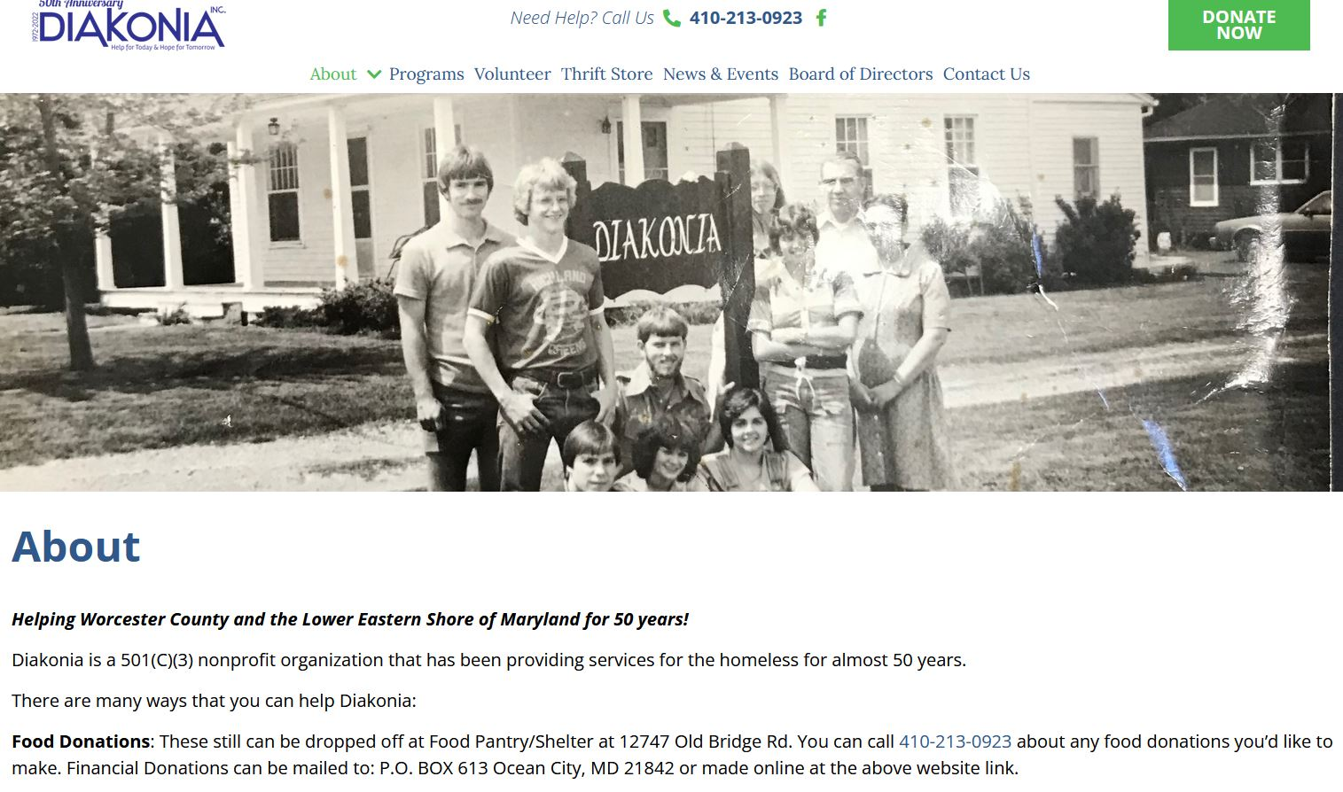
Dollar Energy Fund
Phone: 1-888-282-6816 (Utility Assistance) 412-431-2800 (Administrative)
Email/Contact: dollarenergy.org/contact
Website: dollarenergy.org
Address: Dollar Energy Fund, Inc., P.O. Box 42329 Pittsburgh, PA 15203-0329

Dollar Energy Fund is a non-profit organization spreading across multiple states, partnering up with hundreds of different community-based organizations that assist people through several programs including Columbia Gas of Maryland and Maryland American Water Hardship Program. The Maryland American Water Hardship Program, which is administered by Dollar Energy Fund, assists eligible utility customers with their Maryland American Water bills. Customers may receive a one-time grant applied directly to their utility bill.
- In order to apply for the program, a person needs to be referred to an agent that is partnered with them. One such agency is the social services of the Salvation Army. To connect with them, call them on their social services line at 410-749-7771, ext. 205. The Salisbury Corps administration office is located at 215 Vine Street Salisbury, MD 21804.
- To jump immediately to the Maryland American Water Hardship Program on the web to read up on more information as well as a fact sheet, go to the following website:
dollarenergy.org/need-help/maryland/maryland-american-water
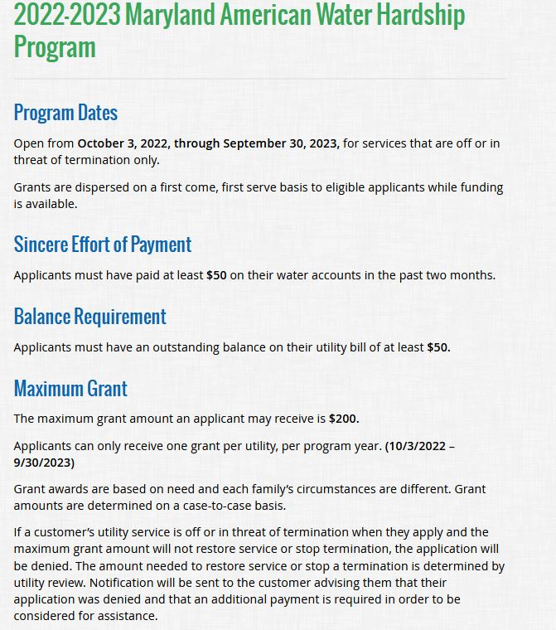The Joseph House
Phone: 410-742-9590
Email/Contact: LSJM@comcast.net
Website: thejosephhouse.org
Address: 411 North Poplar Hill Avenue Salisbury, MD 21802

Crisis Center (For requesting assistance with bills)
Phone: 410-749-4239
Address: 812 Boundary Street Salisbury, MD 21802

A non-profit organization headed by the Little Sisters of Jesus and Mary; they dedicate their work in helping those in need.
An image taken from their website about how acquiring financial assistance works:
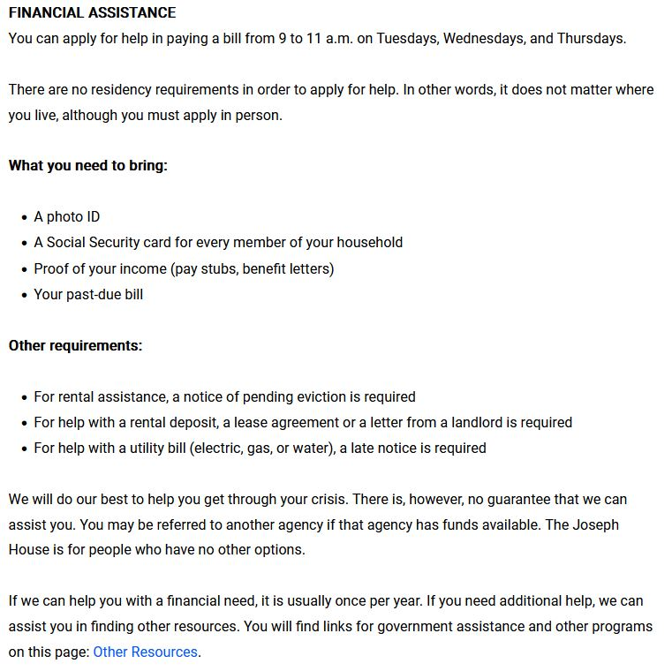
Salvation Army (Salisbury)
Phone: 410-749-7771, ext. 205 for social services
Email/Contact: salisbury.salvationarmypotomac.org/salisbury/contact-us
Website: salisbury.salvationarmypotomac.org/salisbury/home
Address: 215 Vine Street Salisbury, MD 21804 (Admin & Social Services)

The Salvation Army is an international organization dedicated to its mission to provide services and goods to families and children in need. While a Salvation Army thrift store does exist in Salisbury, they also have a social services office located in the area as well, prepared to assist people in need of food, rental & utility relief. The best method in contacting them is through their social services number, or by following the link in the Email/Contact heading.
Contacting the social services of the Salvation Army Salisbury Corps provides the necessary contacts and references to several programs, such as Dollar Energy Fund and their Maryland American Water Hardship Program.
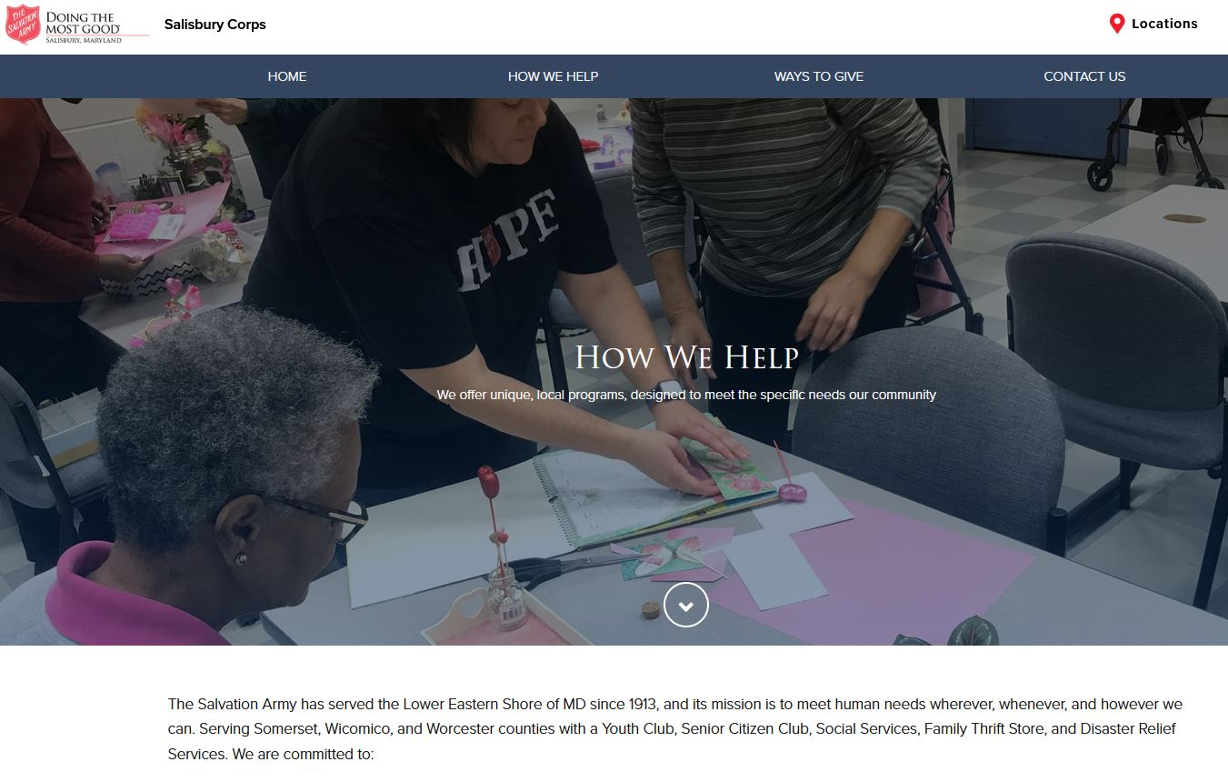
Seton Center (Catholic Charities Diocese of Wilmington)
Phone: 410-651-9608
Email/Contact: ccwilm.org/contact-us
Website: ccwilm.org
Address: 30632 Hampden Avenue Princess Anne, MD 21853

A grant-funded organization that stretches several cities in Delaware such as Wilmington and Dover and has a local office in Princess Anne. Serving the eastern shore, including Worcester, they provide assistance in the form of food distribution, basic needs, support groups, and being able to assist with utilities. While Seton Center does provide relief for the water and sewer service, they would first direct the person to Diakonia, and if they cannot assist then Diakonia would give the referral to Seton Center. Grant funding is given in July and is limited.
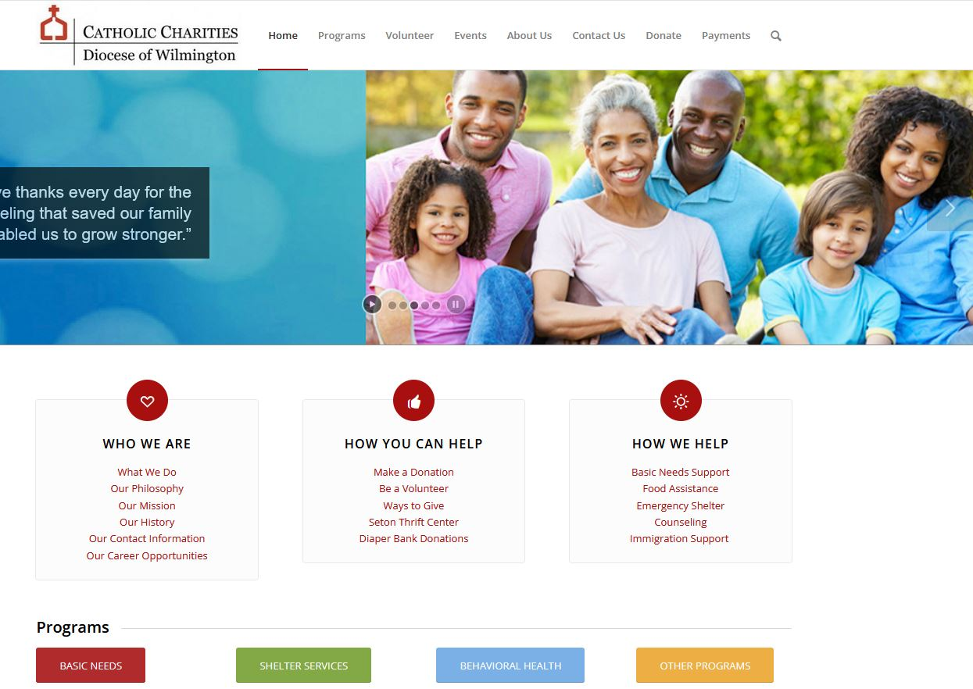
SHORE UP! Inc.
Phone: 410-749-1142
Email/Contact: https://shoreup.org/contact-us/ -OR- agency@shoreup.org
Website: shoreup.org
Address: 520 Snow Hill Road Salisbury, MD 21804-6031

A local, non-profit private organization in Salisbury, SHORE UP! offers a wide range of benefits and assistance programs who receive funding mostly from federal and state grants. While SHORE UP! covers a wide range of assistance such as housing and energy assistance, and most people can apply for multiple programs at the same time, SHORE UP! does not provide relief specifically for Water/Wastewater. The purpose of including SHORE UP! is to provide an additional local source that can potentially assist in other areas of struggle so that more can be used to help cover the water/wastewater expenses.
- To apply, applications are readily available at their place of business, or complete the online form to have someone contact you.
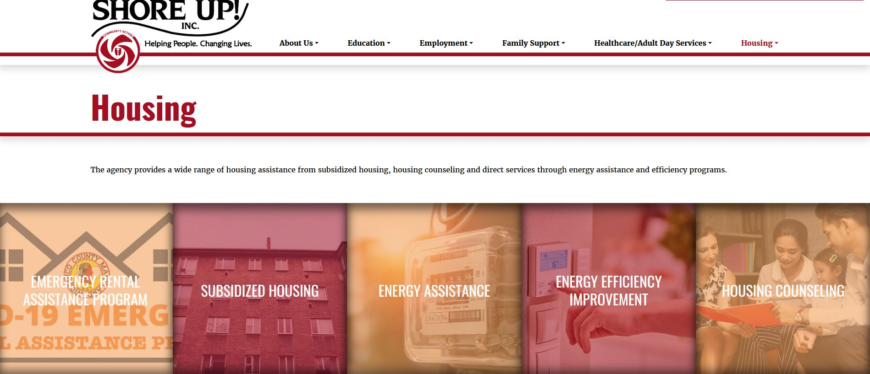
Worcester Youth & Family Counseling Services
Phone: 410-641-4598
Email/Contact: shine@gowoyo.org
Website: gowoyo.org
Address: 124 North Main Street, Suite C Berlin, MD 21811

An organization dedicated to assisting families and youths with local resources in Worcester County. Upon hearing the needs and the conditions of those who contact them, Worcester Youth & Family Counseling Services will then match that person to multiple resources that they qualify for. They offer and can connect to various programs such as Comprehensive Counseling, Worcester Connects, Worcester Navigation and Youth Programs. Those who qualify for any of these programs such as Worcester Navigation could expect to benefit from its features such as job readiness training, wellness services, financial assistance and more.
Worcester Youth & Family Counseling Services have few requirements:
- The resident must live in Worcester County
- They must prove that they need assistance/funds
- It is managed on a case-by-case basis
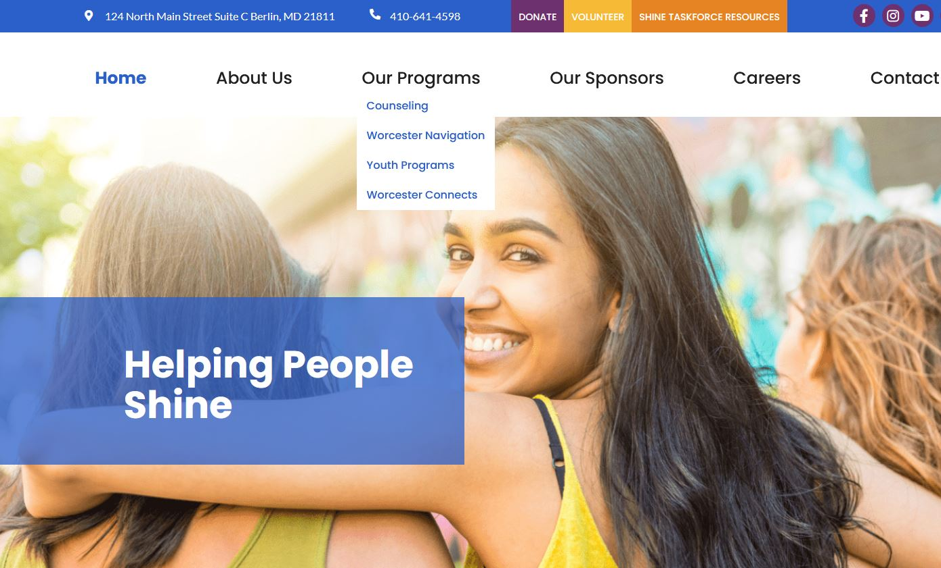
Worcester County GOLD
Phone: 443-235-6525
Email/Contact: contact@worcestergold.org
Website: worcestergold.org
Address: PO Box 335 Snow Hill, MD 21863

A 501(c)(3) non-profit organization, Worcester County GOLD, Inc. promotes dignity by providing financial aid for families in crisis, vulnerable adults, and children in foster care. GOLD serves as a safety net to meet emergency needs for local citizens; promoting the welfare of infants and children, families in crisis, those who are homeless, and vulnerable adults in Worcester County. GOLD offers multiple programs, such as the Emergency Financial Assistance Program, which can assist in water & sewer relief and in other areas of need.
In order to obtain assistance from Worcester County GOLD, a referral from one of its partners must be established. These partners included, but are not limited to:
- Diakonia – (410-213-0923)
- Go-Getters – (443-859-7774, Referrals Office)
- Maryland Access Point of Worcester County (410-632-9915) -OR- (1-884-627-5465)
- Worcester County Department of Social Services – (410-677-6800)
- Worcester County Health Department - (410-632-1100)
- Worcester Navigation Program – (410-641-4598)
Churches/Ministries
The following list of churches/ministries are most of the religious establishments local to the area of Snow Hill and may provide a small source of relief. It is highly recommended to contact each church for any details needed in order to be eligible for any assistance they do offer.
For a more exhaustive list, please visit: yellowpages.com/snow-hill-md/churches

All Hallows Episcopal Church
410-632-2327 - 109 W Market Street Snow Hill, MD 21863

Bates Memorial United Methodist Church
410-632-1319 - 116 N Washington Street Snow Hill, MD 21863

Bowen & Trinity United Methodist Church
410-632-1134 – 8426 Newark Road Newark, MD 21841

Ebenezer United Methodist Church
410-632-1379 – 107 S Collins Street Snow Hill, MD 21863

First Baptist Church of Girdletree
410-632-1153 - 5912 Taylor Landing Road Girdletree, MD 21829

Free Indeed Baptist Ministries
410-632-3380 – 418 W Market Street Snow Hill, MD 21863

Friendship United Methodist Church
410-632-3042 – 7609 Shockley Road Snow Hill, MD 21863
Hutts Memorial United Methodist Church
410-632-3616 – 4313 Red House Road Snow Hill, MD 21863

Liberty Church on the Rock
410-632-1580 – 5564 E Market Street Snow Hill, MD 21863

Makemie Memorial Presbyterian Church
410-632-1698 – 115 Franklin Street Snow Hill, MD 21863

Mt Olive United Methodist Church
410-422-7606 – 7442 Mount Olive Church Road Snow Hill, MD 21863

Mt Wesley Church
- 632-3831 - 7022 Scotland Road Snow Hill, MD 21863

New Collins Temple AME
410-632-2029 – 6009 Castle Hill Road Snow Hill, MD 21863

New Jerusalem Holy Church
410-632-1580 – 5564 E Market Street Snow Hill, MD 21863

Seventh-day Adventist Church
410-957-3863 – 1941 Old Virginia Road Pocomoke City, MD 21851

St James AME Church
410-632-1437 – 5549 Sweetspire Lane Snow Hill, MD 21863

St James Holiness Church
410-632-2234 – 506 Dighton Avenue Snow Hill, MD 21863

St Matthew’s Church
410-632-1116 - 7209 Cherrix Road Girdletree, MD 21829

Shiloh Methodist Church
410-957-0197 – 2655 Worcester Highway Pocomoke City, MD 21851

Spence Baptist Church
410-632-3077 – 7603 Spence Church Road Snow Hill, MD 21863

Snow Hill Christian Church
410-632-2129 – 300 Park Row Snow Hill, MD 21863

Snow Hill Church of Christ
410-632-0737 – 4848 Washington Street Snow Hill, MD 21863

Snow Hill Mennonite Church
410-632-2734 – 5927 Worcester Highway Snow Hill, MD 21863

Whatcoat United Methodist Church
410-632-2198 – 102 West Federal Street Snow Hill, MD 21863

References

Holloway, J. S. (2023). Rate analysis report for the Town of Snow Hill
U.S. Census Bureau (2021). American Community Survey 5-year estimates. Retrieved from Census Reporter Profile page for Snow Hill, MD http://censusreporter.org/profiles/16000US2473075-snow-hill-md/

