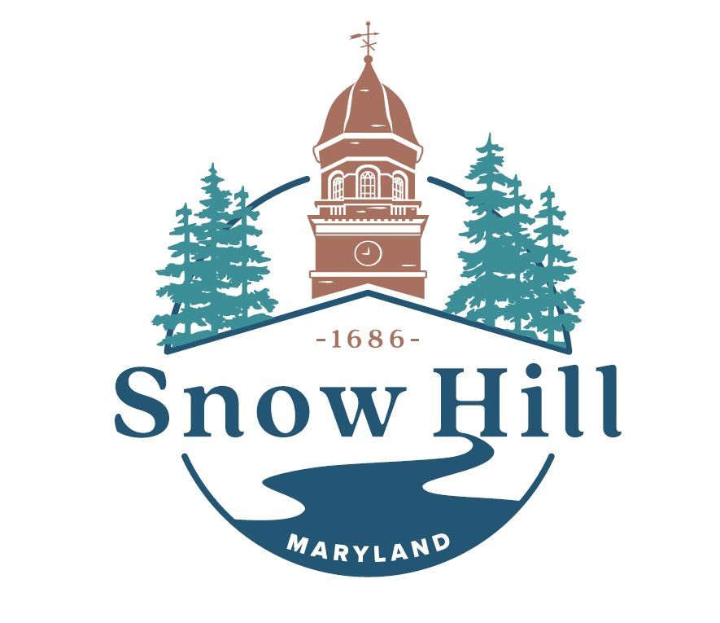

THE SNOW HILL MAYOR & TOWN COUNCIL WILL MEET IN A SPECIAL WORK SESSION AT THE OLD FIREHOUSE ON TUESDAY AFTERNOON, JULY 11, 2023 BEGINNING AT 5:00 PM. AT THIS TIME THE FOLLOWING REPRESENTS THE AGENDA:

Zoom.us/join – ID# : 858 6542 4589

Members of the public can listen to the meeting and participate using the following methods.
  - Attend in person
- Access the meeting real-time online at:
Zoom.us/join – Meeting ID : 858 6542 4589

- Call to Order – Mayor Pruitt
- Special Recognition – New Snow Hill Grants Administrator: Paul Bessette
- Introduction of Special Session – Councilwoman Walsh
Regularly Scheduled Work Session, 1st Tuesday of the month, fell on July 4th, and was canceled in honor of the holiday. The Council requested the Mayor to reschedule the meeting for the purpose of setting goals and priorities for the upcoming fiscal year, 2023-24.
This meeting is intended to be a workshop for Council to discuss goals, to receive public comment, and to hear feedback from the Mayor. Our objective is to begin a working list of Town Council priorities for the year, and to strengthen teamwork.
- Improved Communication between Mayor, TM, Council and Town
D1. Assign 1 council member to regularly communicate with each department during the month
D2. Regular Meetings with Town Hall Staff as items are being addressed, researched and developed.
D3. Department Heads present at meetings to give updates of their
activity/departments and to receive public comment
D4. Be advised of reports of various Commissions and Committees on their meetings
(Organization Committee, Downtown Snow Hill, Economic Vitality Team, Promotion Committee, Chamber of Commerce, Housing Review Board, Planning Commission)
- Grants Administration
E1. Reports on Grant Awards and allocation of monies (Sturgis and Byrd Parks, Coulbourne Lane, ARPA)
E2. Training for new hire
E3. Formation of Committee for Sustainability Communities Grant Application
- Committee Formation
F1. For establishing guidelines on recreational marijuana use and Sales
F2. For updating Comprehensive Plan
- Zoning and Planning
G1. What are plans and intentions for vacant Town properties, both that the Town owns and that have been abandoned
G2. Summerfield/Odachowski plans are being revived
G3. W Market Street Development
G4. Is there a proposal for Site of police bldg. on W Market
G5. PNC bank options
G6. Rowhouses on Water Street

H. Code Enforcement
H1. Discuss how complaints about town codes are received and addressed
H2. Code enforcement as a function of town govt.
H3. Bldg. Permits displayed
H4. Annual Rental Inspections
H5. How are fines imposed and collected

- Council Add-ons (Bike Path Progress, BES Remaining Debt Amount, Water Bill assistance, Drug Sales in Byrd Park)
- Mayor and TM
- Public Comment
- Adjourn

