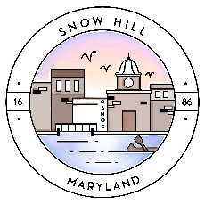

Mayor and Council Work Session
April 21, 2020 4:30 pm

ATTENTION RESIDENTS:
This meeting will be held
Via TELEPHONE CONFERENCE
(following COVID-19 State protocols)

AGENDA

- Minutes – review for approval
- HUD Loan application – Brews Up
- Election
- Audit Proposals

Please note:

- All PUBLIC meetings will be held via telephone conferencing until further notice.
- You can participate in meetings by calling (425)436-6310, then entering access code 428764, and press #. This will enter you into the conference.
- Meetings will be recorded and available to the public.

Part of the meeting may be closed to the public in accordance with
Open Meetings Act procedures.
This agenda may be subject to change.

